**ELEMENTS OF POWER SYSTEMS**

**EXPERIMENT 1**

**STAR DELTA CONFIGURATION:**

**Code:**

clc

clear all

fprintf('for star-delta')

Vl = 230;

P = 10^4;

cos = 0.9;

Il = P/((3^0.5)*Vl*cos)

Vp = Vl/(sqrt(3))

Ip = Il;

Z = (sqrt(3)*Vl)/Ip

**Output:**

Il = 27.8913

Vp = 132.7906

Z = 14.2830

**Circuit Diagram:**

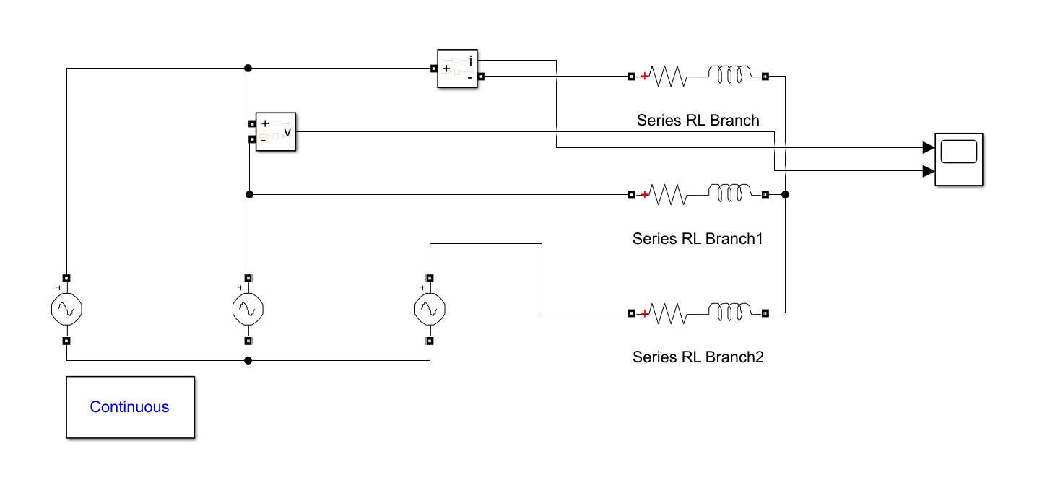

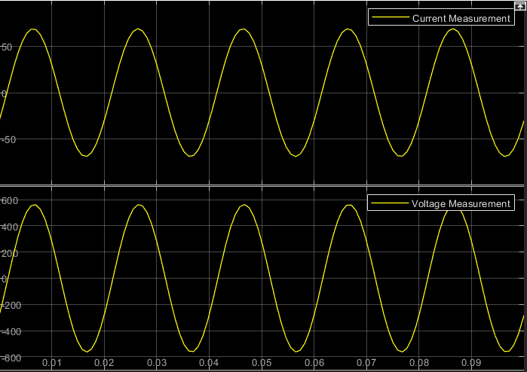**Waveform:**

**STAR STAR CONFIGURATION:**

**Code:**

clc

clear all

%star-star

Vl=230;

p=10*10^3;

costheta=0.9;

Il=p/(sqrt(3)*Vl*costheta)

z=Vl/((Il)*sqrt(3));

fprintf('The line current is %f',Il)

fprintf('The z is %f',z)

**Output:**

Il = 27.8913

The line current is 27.891317

The z is 4.761000

**Circuit Diagram:**

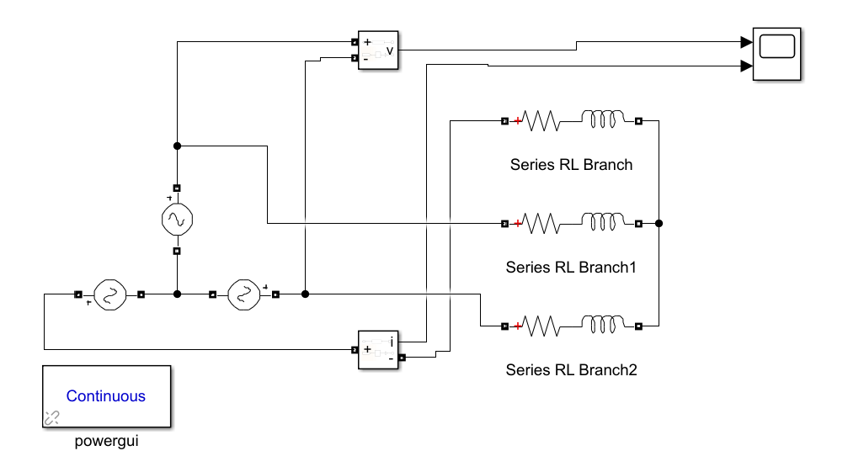

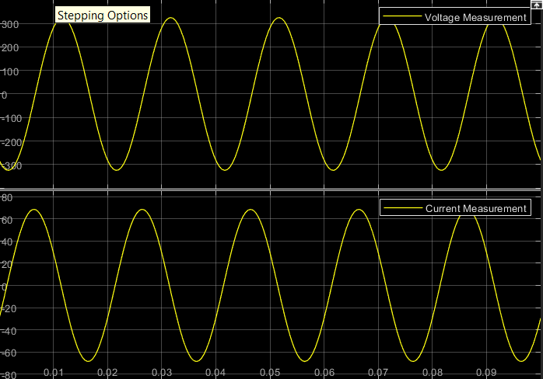**Waveform:**